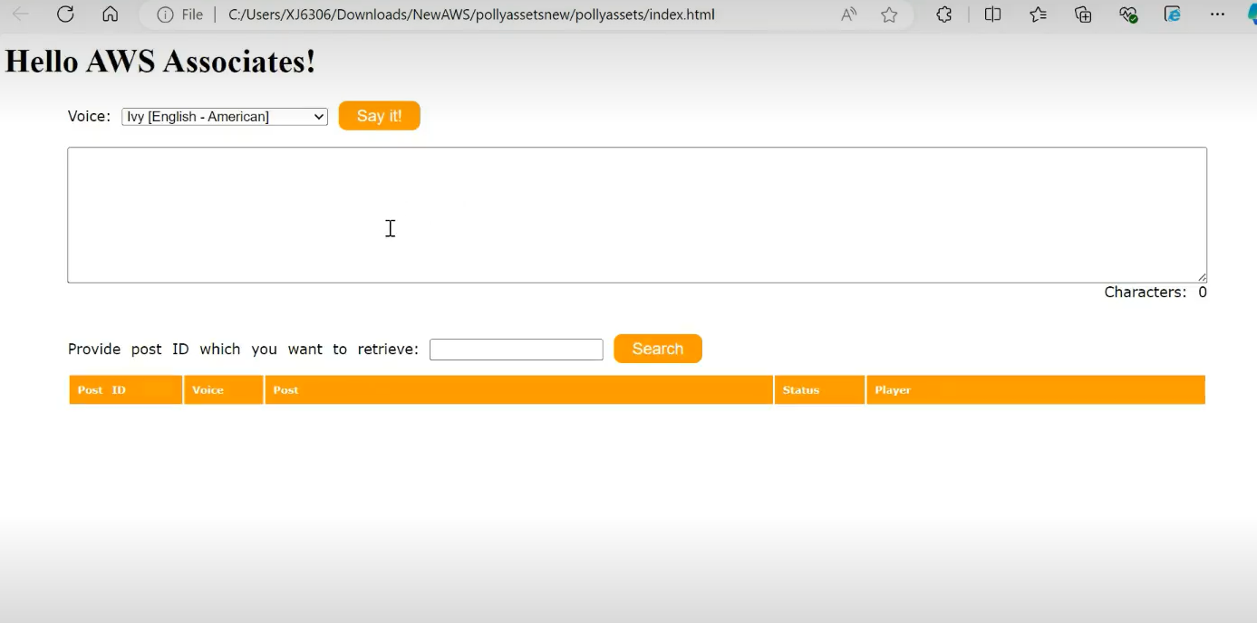  
There will be one application in the backend of this web page.

This will be the architecture for creating functionality of above shown web page using AWS Lambda Functions.

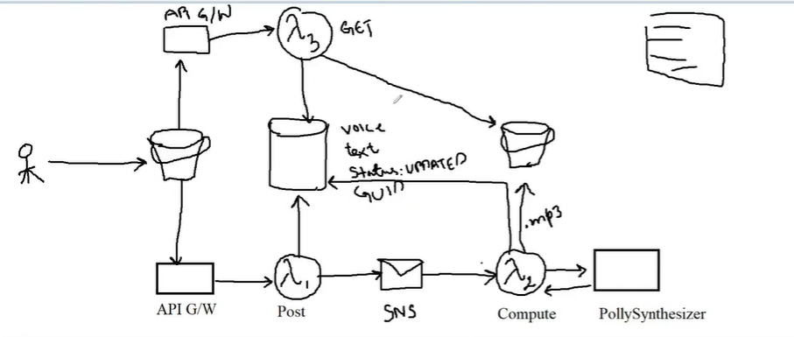

**Steps To achieve Lambda functionality:**

1. **Create two s3 bucket**
2. **Attach policies to both buckets**
3. **Create SNS topic**
4. **Create one table**
5. **Create role for lambda**
6. **Create first lambda function (Post)**
7. **Set environment variable of lambda**
8. **Create second lambda function (Compute)**
9. **Add trigger to compute**
10. **Create third function (get)**

**(Note: Whenever we try to get output from DB using API Gateway. Then in API Gateway we need to declare query parameter and its value.**

1. **Go to API G/W (Create rest API)**
2. **Using option method we can integrate all method but for that we have to make CORS enabled**
3. **Deploy API**
4. **Copy path after deploying API past that URL in JS script.**
5. **In first bucket upload all the frontend files**